***USE HERBS AS GROUND COVER***

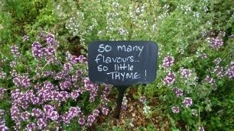 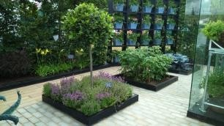

Make thyme for herbs

Herbs have so many different uses in the garden – I use them as hedges, in my green roof and for scented ground cover. In this garden both thyme and rosemary are used to cover the ground beneath the trees. As well as looking good, they bring in pollinating insects and provide leaves for stews, soups and marinades. My favourite ground cover herb is creeping thyme (Thymus serpyllum). It’s pretty indestructible, drought tolerant and softens the hard edges of the stepping stones with their delicate leaves.